Single nand
Root cell box:
width x height ( llx, lly ), ( urx, ury ) area (units^2)

microns: 9.60 x 30.00 ( -1.80, -1.20 ), ( 7.80, 28.80) 288.00
lambda: 32 x 100 ( -6, -4 ), ( 26, 96 ) 3200

Z modules in Logarithmic Funnel Shifter has 3 NAND gates at most. We decided to put them like the following:

Therefore the Z modules will have
have more square shape. We decided
to put one of the NAND gates
slightly down to be able to connect
to the inputs more easily. This may
be even more extreme therefore,
we will account for that in our calculation.

32 * 3 + 24 = 120
32 lambda wide each NAND and 8 space
in between.

100 + 60 = 160
40 extra space for moving the NAND gates up and down for easy connection.

120 * 16 = 1920
is the total width of the Logarithmic Funnel Shifter (multiplied by 16 to account for extra needed space)

Single Mux2

Root cell box:
width x height ( llx, lly ), ( urx, ury ) area (units^2)

microns: 16.80 x 30.00 ( -1.80, -1.20 ), ( 15.00, 28.80) 504.00
lambda: 56 x 100 ( -6, -4 ), ( 50, 96 ) 5600

If we have 3 mux2s and a Z module for the total height:

160 + 3*30 + 200 = 450
Extra 200 is for the inputs and the space in between the horizontal placing.

Therefore, our shifter module would be 1920 * 450 lambdas in terms of size.

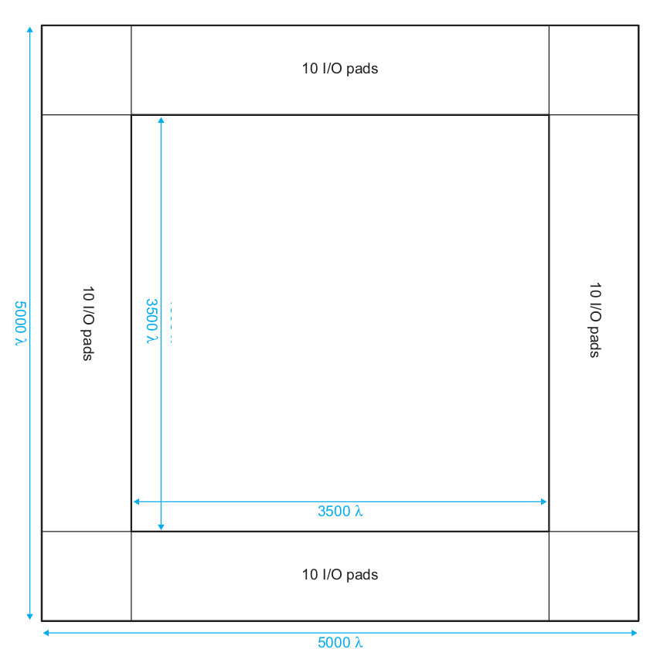
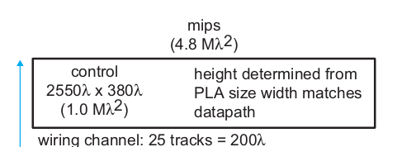
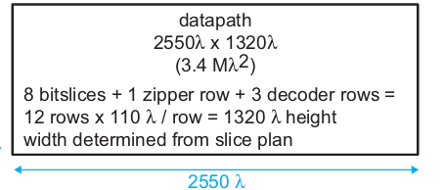
The extra space on the left of the Shifter will be used either for the Datapath to be expanded up or will be used for the extra space needed for the shifter that was previously not calculated. Also, the controller may need some modifications.
Shifter
1920 * 450 lambda
Calculations above

We decided to put the shifter in between controller and the datapath so that the connections in between would be easier. Shifter only has a limited amount of inputs and outputs whereas breaking up the datapath might had been more difficult. Our design may change as we come to realize further complications.
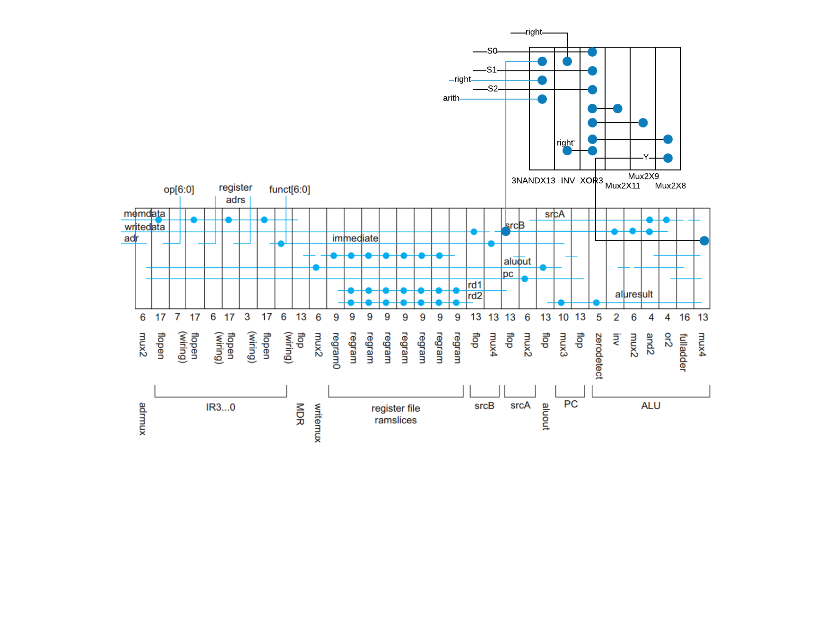
Slicing plan with shifter

